

**Haringey’s Foster Carers**

**Training Brochure**

**2021**

**Content**

|  |  |
| --- | --- |
| Welcome | 4 |
| Foster Carers Learning and Development Pathways | 5 |
| Training Calendar | 6,7 |
| KCA Online Training | 8,9,10, 11 |
| Core Training Courses | 12 |
| Child Protection for Foster Carers | 13 |
| Conflict Management | 14 |
| First Aid | 15 |
| Managing Allegations and Safer Caring | 16 |
| Managing Challenging Behaviour | 17 |
| Prevent | 18 |
| Recording and Sharing Information / Data Protection | 19 |
| Safer Caring and Delegated Authority | 20 |
| Non – Core Training | 21 |
| Attachment, Separation and Loss | 22 |
| Basic Drug Awareness | 23 |
| Breaking Down Barriers, Bettering Behaviour / Building on Brilliance | 24 |
| Building Memory Box | 25 |
| Child Exploitation | 26 |
| Early years And Medical Advice training | 27 |
| Equality Diversity & Identity | 28 |
| ESOL | 29 |
| Hidden Harm | 30 |
|  |  |
| I T / COMPUTER SKILLS | 31 |
| LGBT and Awareness Workshop | 32 |
| Missing from Care | 33 |
| Voice of the Child | 34 |
| Watch me play | 35 |
| Do you want to a Haringey Foster Carer? | 36 |

Please note all training courses / workshops will be delivered virtually (MS Teams) and a joining link will be sent once your place has been booked.

**To book on any of these courses please email Gillian Bhola;**

[**Gillian.Bhola@haringey.gov.uk**](mailto:Gillian.Bhola@haringey.gov.uk)**.**

**Or inform your Supervising Social Worker.**

**A Warm Welcome**

We are very excited to share our training programme which contains learning and development opportunities that provide an essential foundation for all Foster Carers, as well as more specialist modules to ensure that all our carers can meet the needs of children and young people in their care. In Haringey, we are constantly striving to provide children and young people high quality care, leading to good life outcomes for them.

Children who come into the care system increasingly have a complexity of needs and backgrounds. The professionals working with these children require to be highly skilled and well informed. We consider that taking advantage of training and development opportunities are central to a carer’s own development and to achieving this aim to provide high standards of care and great outcomes for children.

We hope that our training programme will help you enhance your skills, be better informed about key developments in legislation and research, as well as adopt best practice in the field of childcare.

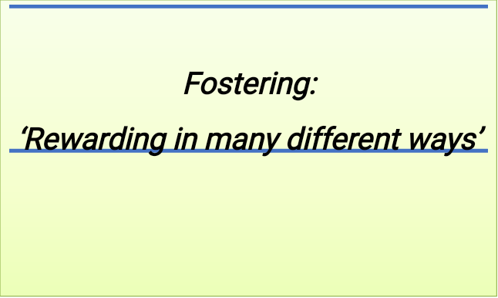

**Foster Carers’ post approval Learning and Development Pathways: Evidencing the Standards**

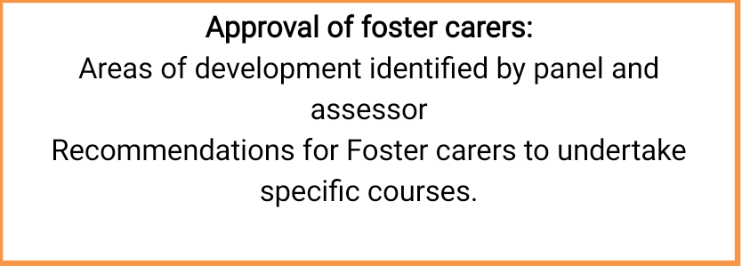





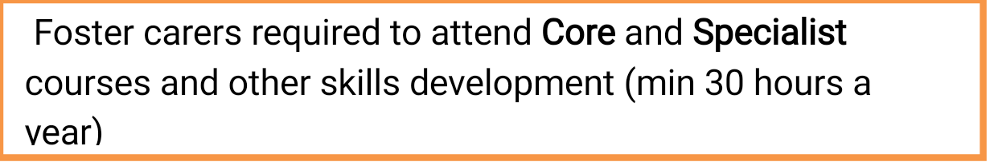



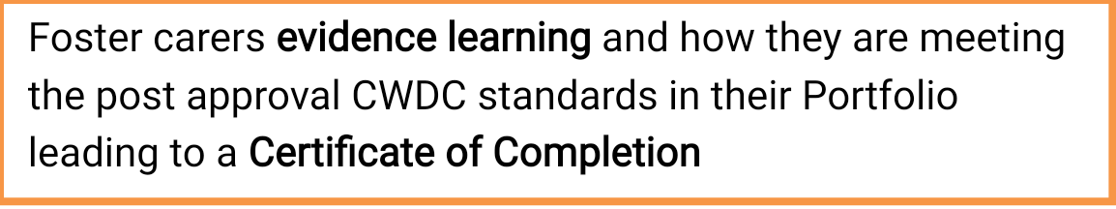





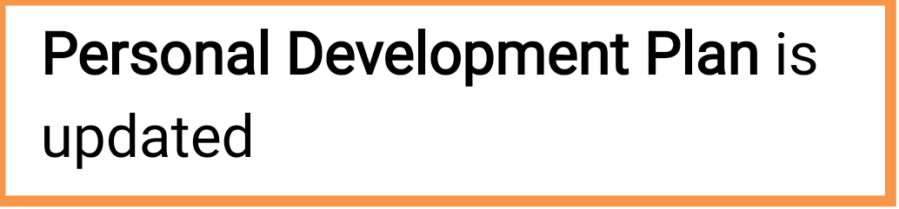











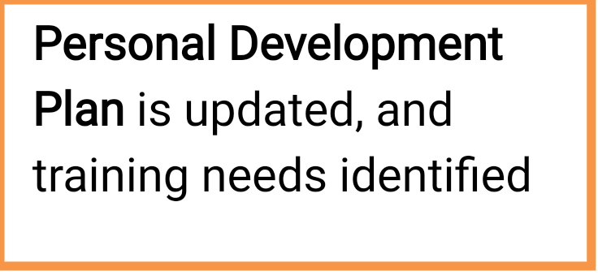

**Training Calendar 2021**

|  |  |
| --- | --- |
| January |  |
| 11th | First Aid |
| 14th | LGBTQI Training / (Foster Carers / Male Carers Group) |
| 19th | Managing allegations and safer caring |
| 21st | Early years medical Advice training |
|  |  |

|  |  |
| --- | --- |
| February |  |
| 8th | Recording and sharing information |
| 9th | Breaking Down Barriers, Bettering Behaviour and Building on Brilliance |
| 10th | Safer caring and Delegated Authority |
| 11th | Male Carer’s Support Group - Basic Drug Awareness |
| 12th | Child Protection |
|  |  |

|  |  |
| --- | --- |
| March |  |
| 3rd | Building Memory Box |
| 18th | Missing from Care |
| 25th | Hidden Harm |
|  |  |

|  |  |
| --- | --- |
| April |  |
| 15th | Male Carer’s Group - TBC |
| 21st | Managing Challenging behaviour |
| 26th | Managing allegations and safer caring |
|  |  |

|  |  |
| --- | --- |
| May |  |
| 4th | Equality Diversity & Identity |
| 5th | Recording and sharing information |
| 10th | Safer Caring and Delegated Authority |
| 13th | Male Carer’s Group - TBC |
| 14th | Watch me play |
| 20th | Breaking Down Barriers, Bettering Behaviour and Building on Brilliance |
| 26th | First Aid |
|  |  |

|  |  |
| --- | --- |
| June |  |
| 9th | Building Memory Box |
| 10th | Child Protection |
| 17th | Early years medical Advice training |
| 17th | Male Carer’s Group |

|  |  |
| --- | --- |
| July |  |
| 2nd | First Aid |
| 15th | Male Carer’s Group |
| 16th | Managing challenging behaviour |
|  |  |

**August – School Holidays / No Training**

|  |  |
| --- | --- |
| September |  |
| 7th | Safer Care and Delegated Authority |
| 13th | Managing allegations and safer caring |
| 14th | Equality Diversity & Identity |
| *21st* | Breaking Down Barriers, Bettering Behaviour and Building on Brilliance |
|  |  |

|  |  |
| --- | --- |
| October |  |
| 1st | Child Protection |
| 5th | Managing challenging behaviour |
| 20th | First Aid |
|  |  |

|  |  |
| --- | --- |
| November |  |
| 9th | Recording and sharing information |
| 17th | Building Memory Box |
|  |  |

|  |  |
| --- | --- |
| December |  |
| 7th | Equality Diversity & identity |
| 10th | Male Carers Support Group |
| 14th | Managing allegations and safer caring |
|  |  |

**KCA Online Training**

**Knowledge. Change. Action**

“*Knowledge can be transformative. When it enables us to make sense of the world in new ways, we can begin to act in new ways, and we can change the world.*

*“****Kate Cairns***

**KCA Online** is an eLearning platform which provides online and face-to-face training as well practice tools and reference materials. The online courses aim to develop knowledge, skills and reflection not by taking people out of their workplace, but rather by sending them to explore their workplace and their work relationships as part of an ongoing learning journey.

Activities and exercises require learners to 'stop and think' or 'go and do' and to record their discoveries. Although the learning is guided online, with input from experts, in reality people are learning from and alongside their managers, colleagues and service users.

|  |  |  |
| --- | --- | --- |
| [**Adolescence**](https://connected.kca.training/courses.cfm?action=view&course=424) |  |  |
| [**Assessing and managing risk**](https://connected.kca.training/courses.cfm?action=view&course=123) |  |  |
| [**Attachment and brain development**](https://connected.kca.training/courses.cfm?action=view&course=65) |  |  |
| [**Behaviour and the physical environment**](https://connected.kca.training/courses.cfm?action=view&course=140) |  |  |
| [**Behaviour and the physical environment: Adapting the physical environment to promote recovery from trauma**](https://connected.kca.training/courses.cfm?action=view&course=292) |  |  |
| [**Brain development and positive parenting**](https://connected.kca.training/courses.cfm?action=view&course=180) |  |  |
| [**Building individual and community resilience**](https://connected.kca.training/courses.cfm?action=view&course=286) |  |  |
| [**Building resilience**](https://connected.kca.training/courses.cfm?action=view&course=168) |  |  |
| [**Child development**](https://connected.kca.training/courses.cfm?action=view&course=99) |  |  |
| [**Child protection**](https://connected.kca.training/courses.cfm?action=view&course=158) |  |  |
| [**Child protection – Scotland**](https://connected.kca.training/courses.cfm?action=view&course=187) |  |  |
| [**Child sexual exploitation: Protecting children and young people from harm**](https://connected.kca.training/courses.cfm?action=view&course=344) |  |  |
| [**Child-centred assessment**](https://connected.kca.training/courses.cfm?action=view&course=95) |  |  |
| [**Children and young people who misuse substances**](https://connected.kca.training/courses.cfm?action=view&course=431) |  |  |
| [**Children's rights**](https://connected.kca.training/courses.cfm?action=view&course=105) |  |  |
| [**Communicating with children and young people**](https://connected.kca.training/courses.cfm?action=view&course=59) |  |  |
| [**Community resilience and secondary trauma: Maintaining well-being in the public service workforce**](https://connected.kca.training/courses.cfm?action=view&course=973) |  |  |
| [**Community resilience and toxic stress: Working with trauma across the lifespan**](https://connected.kca.training/courses.cfm?action=view&course=972) |  |  |
| [**Confidentiality and record keeping**](https://connected.kca.training/courses.cfm?action=view&course=118) |  |  |
| [**Contact in foster care**](https://connected.kca.training/courses.cfm?action=view&course=126) |  |  |
| [**Domestic violence**](https://connected.kca.training/courses.cfm?action=view&course=109) |  |  |
| [**Eating disorders: A relationship-based approach to prevention and recovery**](https://connected.kca.training/courses.cfm?action=view&course=400) |  |  |
| [**Emotion coaching**](https://connected.kca.training/courses.cfm?action=view&course=179) |  |  |
| [**Emotion coaching: A systemic, relational approach to behaviour**](https://connected.kca.training/courses.cfm?action=view&course=271) |  |  |
| [**Equality and diversity**](https://connected.kca.training/courses.cfm?action=view&course=56) |  |  |
| [**Equality and diversity in professional practice**](https://connected.kca.training/courses.cfm?action=view&course=281) |  |  |
| [**EY Early identification and action: Special Educational Needs and Disabilities in the early years**](https://connected.kca.training/courses.cfm?action=view&course=584) |  |  |
| [**EY liaising with professionals or agencies beyond the setting**](https://connected.kca.training/courses.cfm?action=view&course=664) |  |  |
| [**EY Supporting colleagues in their work with children with SEND**](https://connected.kca.training/courses.cfm?action=view&course=665) |  |  |
| [**EY The role of the early years SENCO**](https://connected.kca.training/courses.cfm?action=view&course=586) |  |  |
| [**Five to Thrive for Life: Adolescence**](https://connected.kca.training/courses.cfm?action=view&course=364) |  |  |
| [**Foetal alcohol spectrum disorders: Systemic approaches to improving life chances for children and young people**](https://connected.kca.training/courses.cfm?action=view&course=230) |  |  |
| [**Foetal exposure to alcohol**](https://connected.kca.training/courses.cfm?action=view&course=306) |  |  |
| [**Impulsive behaviour**](https://connected.kca.training/courses.cfm?action=view&course=86) |  |  |
| [**Introduction to child development**](https://connected.kca.training/courses.cfm?action=view&course=346) |  |  |
| [**Introduction to child protection**](https://connected.kca.training/courses.cfm?action=view&course=349) |  |  |
| [**Introduction to communicating with children and young people**](https://connected.kca.training/courses.cfm?action=view&course=347) |  |  |
| [**Introduction to promoting secure attachment: Brain development and positive parenting**](https://connected.kca.training/courses.cfm?action=view&course=356) |  |  |
| [**Introduction to understanding trauma**](https://connected.kca.training/courses.cfm?action=view&course=328) |  |  |
| [**Making safe connections – the digital revolution, neuroscience and human attachment needs**](https://connected.kca.training/courses.cfm?action=view&course=409) |  |  |
| [**Maladaptive behaviours: Promoting recovery for children who harm themselves**](https://connected.kca.training/courses.cfm?action=view&course=291) |  |  |
| [**Men in children's services**](https://connected.kca.training/courses.cfm?action=view&course=146) |  |  |
| [**Multi-disciplinary working**](https://connected.kca.training/courses.cfm?action=view&course=100) |  |  |
| [**Narrative work**](https://connected.kca.training/courses.cfm?action=view&course=164) |  |  |
| [**Narrative work: The development of a positive sense of self**](https://connected.kca.training/courses.cfm?action=view&course=290) |  |  |
| [**Professional development**](https://connected.kca.training/courses.cfm?action=view&course=120) |  |  |
| [**Safer caring**](https://connected.kca.training/courses.cfm?action=view&course=878) |  |  |
| [**Secondary trauma**](https://connected.kca.training/courses.cfm?action=view&course=850) |  |  |
| [**Secondary trauma and community resilience**](https://connected.kca.training/courses.cfm?action=view&course=851) |  |  |
| [**Self-harming behaviours**](https://connected.kca.training/courses.cfm?action=view&course=96) |  |  |
| [**Self-injuring and self-sabotaging behaviours: A relationship-based approach to prevention and recovery**](https://connected.kca.training/courses.cfm?action=view&course=430) |  |  |
| [**Sexualised behaviour: Issues in foster care**](https://connected.kca.training/courses.cfm?action=view&course=112) |  |  |
| [**Sexualised behaviour: Managing risk, promoting recovery**](https://connected.kca.training/courses.cfm?action=view&course=289) |  |  |
| [**Supervising foster care**](https://connected.kca.training/courses.cfm?action=view&course=113) |  |  |
| [**Teamwork**](https://connected.kca.training/courses.cfm?action=view&course=175) |  |  |
| [**The role of the foster carer**](https://connected.kca.training/courses.cfm?action=view&course=929) |  |  |
| [**Transitions and vulnerability**](https://connected.kca.training/courses.cfm?action=view&course=104) |  |  |

**Core Training Courses**

These learning and development opportunities are deemed as being an essential foundation for all foster carers. Foster Carers may require additional learning and development opportunities at any point to ensure that they can meet the needs of the children and young people in their care. As a minimum, we would expect you to attend at least 3 of these core training courses within your first year of fostering.

All carers need to attend safeguarding children and safer caring training every 2 years and the first aid course must be refreshed every 3 years.

* Child Protection
* Conflict Management
* First Aid
* Managing Allegations and safer caring
* Managing Challenging Behaviour
* Prevent
* Recording and Sharing Information /Data Protection
* Safer Caring / Delegated Authority

|  |
| --- |
| **Child Protection for Foster**  **Carers** |
| This course will ensure participants knowledge and commitment to  safeguarding is current and their required knowledge is refreshed.    **Learning Outcomes**   * Explore the concept of safeguarding * Understand thresholds and referrals * Examine the role for a carer in safeguarding processes including a CP conference * Exploring child sexual exploitation in the family and the community: the links to neglect and DV/domestic abuse * Understanding the process of grooming. |
| **Training, Support and Development Standards**   * 6.1, 6.2, 6.3, 6.4   **National Minimum Standards**   * 1.0, 4,5,4.6 |

**Training Details**



* **Date:** 12th February 2021

10th June 2021

1st October 2021

* **Time:** 10:00am – 1:00pm
* **Trainer:** Dawn Green

**Conflict Management**

The course is to support young people in care and their carers to manage conflict effectively and to give them the tools to build safe, supportive and stable relationships.

**Learning Outcomes**

* Gain a better understanding of your relationship to conflict
* Learn tools and strategies to manage conflict better
* Be more confident to communicate your feelings in challenging situations to support you to get the outcome you want
* Have the opportunity to share experiences and challenges with other foster carers and receive support from the group

**Training Details**

* **Date:** TBC
* **Time:** TBC
* **Trainer:** LEAP



**First Aid**

This course offers Paediatric First Aid Training for foster carers.

It is aimed at giving attendees the confidence to tackle emergency events as they happen, from how to wrap a bandage to delivering resuscitation.

**Learning Outcomes**

|  |
| --- |
| * Action at an emergency – priorities of treatment * Care of the baby or child who is unconscious but breathing – Recovery position * Care of the child who is unconscious and not breathing – CPR differences between baby & child CPR * Management of the child with a possible spinal injury * Choking – theory and practical * Drowning * What to put in your First Aid Kit * Major and minor bleeds, amputated parts and treatment of clinical shock * Burns & scalds * Poisoning * Head injury – concussion, compression & skull fracture * Medical conditions such as febrile convulsions and meningitis |

**Training Support and Development Standards**

* 3.3, 3.4

**National Minimum Standards**

* 6.1, 6.2, 6.4, 6.5, 6.7, 6.8, 6.9, 6.10 ,6.11

**Training Details**

* **Date:** 11th January 2021

26th May 2021

2nd July 2021

20th October 2020

* **Time:** 10am – 1pm
* **Trainer:** First Aid First Response

**Managing Allegations and Safer Caring**

This course is based on ‘The Fostering Networks’ course material ‘Safer Caring – a new approach’ and the Fostering Regulations Guidance & NMS 2011 (Fostering Network) and enables participants to increase their understanding, review current practice and consider strategies to manage the risks inherent in foster care; taking into consideration the new approach to managing risk that encourages a risk sensible, rather than a risk averse attitude.

**Learning Outcomes**

* Be able to review safer caring principles and practices in order to keep everyone in the foster home safe – and to identify any gaps or areas for development.
* Have identified strategies to prevent the risk of abuse, re-abuse and to minimise the possibility of allegations.
* Have gained knowledge, understanding and guidance on dealing with allegations or complaints
* Understand how to develop a safer caring policy for the child or young person in their care.
* Understand the concept of delegated authority and the importance of ensuring that this is included in the placement plan for the child or young person in placement.
* Have explored and discussed the issues surrounding the use of the Internet, in particular social media and also mobile phones; in regard to safer caring.

**Training Support and Development Standards**

* 3.4, 6.1, 6.2, 6.3, 6.4, 7.2, 7.3

**National Minimum Standards**

* 3.5, 3.7, 3,8, 3.9, 4.1, 4.2, 4.4, 4.6

**Training Details**

* **Date:** 19th January 2021

26th April 2021

13th September 2021

14th December 2021

* **Time:** 10am – 1pm
* **Trainer:** Shauna McAllister

Haringey Designated Officer / Jennifer Roy – foster carer

**Managing Challenging Behaviour**

This course will help foster carers to understand the complexities of challenging behaviours, and will enable them to assess and understand the underlying needs, which can then be addressed through the promotion of alternative constructive behaviours

**Learning Outcomes**

* Understand and define challenging behaviour
* Know the various types of challenging behaviour
* Know the triggers that lead to challenging behaviour
* Know how to effectively deal with challenging situations
* Understand challenging behaviour
* Be aware of strategies to manage challenging behaviour

**Training Details**

* **Date:** 21st April 2021

16th July 2021

5th October 2021

* **Time:** 10am – 1pm
* **Trainer:** TBC

**Prevent**

This offers an introduction to the Prevent duty and explains how it aims to safeguard vulnerable people from being radicalised to supporting terrorism or becoming terrorists themselves

**Training Details**

* <https://www.elearning.prevent.homeoffice.gov.uk/edu/screen1.html>

**Recording and Sharing**

**Information / Data Protection**

|  |
| --- |
| All professionals working with children and young people must know how to keep and  share information. As a foster carer this can involve unique challenges.  This course enables carers to understand the principles that underpin good record keeping,  and how to apply rules of confidentiality within their own work. |

**Learning Outcomes**

* Understand the reasons for keeping different types of records
* Identify which information should be gathered in ways which it can best be

recorded

* Consider the audience for the records and their use
* Understand how to separate fact from opinions and avoid discriminatory comments and value judgements
* Understand and apply the rules of data protection

**Training Support and Development Standards**

* 2, 4

**Training Details**

* **Date:**  8th February 2021



5th May 2021

9th November 2021

* **Time:** 10am – 1pm
* **Trainer:** L&A Training

**Safer Caring and Delegated Authority**

|  |
| --- |
| This course will support and empower carers to make informed decisions regarding day to day tasks for the children in their care, some of these decisions involve an element of risk, such as, sleepovers, school activities and contact with siblings. All delegated authority decisions made by a carer must be within the child’s Placement Plan. |

|  |
| --- |
| **Learning Outcomes**   * Have a full understanding of the meaning and purpose of delegated authority * To have developed confidence in knowing when and when not to delegate authority within the child’s placement plan and ensuring agreements are sought * To consider how carers should make judgements involving elements of risk for the child * To explore issues and concerns around delegated authority including promoting shared perspectives, responsibilities and working together |

|  |
| --- |
| **Training, Support and Development Standards**   * 1, 2,3 and 7     **National Minimum Standards**   * 2, 3, 4, 6, 20, 21 |

**Training Details**

* **Date:** 10th February 2021

10th May 2021

7th September 2021

* **Time:** 10am – 1pm
* **Trainer:** L&A Training

**Non-Core Training**

* Attachment, Separation and Loss
* Basic Drug Awareness
* Breaking down barriers, bettering behaviour and building on brilliance
* Building memory box
* Child Exploitation
* Early years medical advice
* Equality Diversity & Identity
* ESOL
* Hidden Harm
* I T / COMPTER SKILLS
* LGBTQI
* Missing from Care
* Voice of the child

Male Carers Group

* Basic Drug Awareness
* Hidden Harm
* LGBT and Awareness Workshop

|  |
| --- |
| **Attachment, Separation and Loss**  This session will enable carers to develop a wider understanding of attachment  issues for children who are in care. |

**Learning Outcome**

* Have an understanding of attachment
* Have an opportunity to share some of your experiences of caring for children
* Discuss the importance of recognising a looked after child’s attachment to their birth families and previous lifestyles
* Assessing Unresolved Loss/Trauma
* Ways of Understanding Older Children’s Worlds
* The central importance of Relationship Skills
* Moving from Assessment to Helping and Supporting children

**Training Support and Development Standards**

* 2.1, 2.5 and 4.5

**National Minimum Standards**

* 3.3, 3.7, 6.1, 6.8, 6.11

**Training Details**

* **Date:** TBC
* **Time:** TBC
* **Trainer:** TBC

**Basic Drug Awareness**

The aim of this session is to raise awareness of substances and their effects. It will also look at the impact that drugs and alcohol have on an individual as well as on a societal level

**Learning Outcome**

* Educate yourself, to enable Frank conversations with your Children.
* Illicit Substances are being sold on the streets where you live
* Schools are a high target for vulnerable children
* Feel confident in your knowledge, if you discover substances, in a child’s bedroom, how to approach the subject.

**Training Details**

* **Date:** 11th February 2021
* **Time:** 10am – 1pm

**Male Carer’s Group**

* **Time:** 6pm – 8pm

**Trainer:** Mark Render



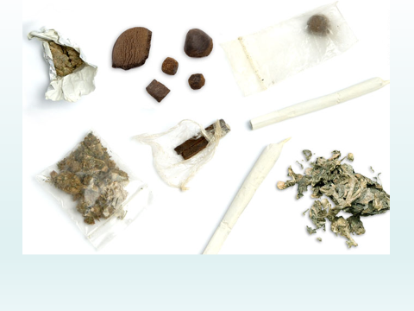

**Breaking Down Barriers, Bettering Behaviour and Building on Brilliance**

This session provides essential training for Foster Carers which covers the context of care in Haringey; the role of key professionals, including Foster Carers, in promoting the education of looked-after children; Personal Education Plan (PEP) procedures; overcoming barriers to learning and current updates from the Virtual School.

**Learning Outcome**

* Have an up-to-date understanding of the roles and responsibilities of the Virtual School and Designated Professionals for looked-after children and young people
* Understand how good educational outcomes, improve children and young people’s life chances.
* To be familiar with the PEP process and how to use Personal Education Plans to ensure a child or young person’s needs are identified and supported in the best way possible.
* How to fully utilise Pupil Premium Plus funding to maximise its impact.
* To better understand the cause of negative behaviours at school and strategies to reduce their impact.

**Training Details**

* **Date:** 9th February 2021

20th May 2021



21st September 2021

* **Time:** 10am – 2pm
* **Trainer:** Head of Haringey Virtual School

**Building Memory Box**

Memory boxes can help to provide children and young people with an enduring account of their lives. This can aid in developing a positive sense of identity and gain an understanding of the transitions they will experience. The course will enable carers to help young people identify positive experiences and happy memories.

**Learning Outcomes**

* Identify the importance of memory boxes
* Establish what is to be included in a memory box and look at ways to encourage young people to engage in the activity
* Identify sources for gathering information
* Look at how identify is constructed and the role they can play in promoting a positive sense of identity
* Identify why self-esteem is important in this area
* Look at different examples of memory boxes

**Training Details**

* **Date:** 3rd March 2021

9th June 2021

17th November 2021

* **Time:** 10:00am – 1:00pm
* **Trainer:** Phyllis Grant

**Child Exploitation**

(CSE) is a form of sexual abuse that involves the manipulation and/or coercion of young people under the age of 18 into sexual activity in exchange for things such as money, gifts, accommodation, affection or status (*Barnardos,2012*).

This three-hour training session enables participants to develop a greater awareness of Child Sexual Exploitation (CSE). Throughout the training you will be encouraged and supported to consider how your own practice can best address and support children and young people at risk or experiencing CSE.

**Learning Outcome**

* Reflect on different values and attitudes and the impact they have when working with young people affected by CSE
* Identify vulnerabilities, behaviours and risk indicators for CSE
* Have an improved understanding of the additional vulnerabilities and risks for young women affected by gangs
* Develop an understanding of legislation, guidance and procedure in relation to CSE
* Have a working knowledge of local referral

**National Minimum Standards**

* 2, 3, 4, 6, 20, 21

**Training Details**

* **Date:** TBC
* **Time:** TBC
* **Trainer:** TBC

**Early years And Medical Advice Training**

Sue Lai and Shellie Bishop are specialist nurses for Children in Care.  They will be presenting current health advice and practice for under-fives general health and wellbeing.

**Learning Outcomes**

* Child development
* Potty/toilet training
* Weaning/nutrition
* Responding to temperatures
* Childhood illness
* Asthma
* Eczema
* Epilepsy
* Promoting a healthy lifestyle
* Bedwetting

**Training Details**

* **Date:** 21st January 2021

17th June 2021

* **Time**: 10am -1pm
* **Trainer:** Sue Lai and Shellie Bishop

**Equality Diversity & Identity**

This course is designed to help foster carers fully appreciate the varied backgrounds that young people originate from, the importance of the child’s journey and the impact of transition between foster placements and leaving their birth family

**Learning Outcomes**

* Manage diversity and promote equality
* Tackle discrimination when it occurs
* Confidently discuss issues of inequality with children/young people and significant others
* Understand the impact placement moves and foster care have on a child’s identity
* Advocate that the needs, rights and views of the child or young person are at the centre of all practice and provision.
* Understand the important role foster carers play in promoting identity
* Illustrate how individuality, difference and diversity are valued and celebrated.
* Explore equality of opportunity, issues and promote anti-discriminatory practice.
* Define and promote social inclusion and advancement of children and young people. Closing the gap in education and employment
* Reflect on the different types of prejudice and discrimination which can affect children and young people in care.
* Outline why it is important to provide care which respects and preserves each child’s protected characteristic as defined by the Equality Act 2010
* Illustrate how you support and encourage children and young people to develop skills to deal with discrimination, enhance self-worth and make a positive contribution.

**Training Details**

* **Date**: 4th May 2021

14th September 2021

7th December 2021

* **Time:** 10am – 1pm
* **Trainer:** L&A Training

**ESOL**

ESOL courses are designed for people whose first language is not English. We offer a variety of courses from pre-entry, beginner courses to Level 2 speaking and listening, as well as a number of employability pathways including Working in Childcare.

**Learning Outcome**

* Develop the skills you need for everyday life in the UK
* Develop your English skills to get a job or improve your work prospects
* Provide you with a qualification in English
* Enable you to progress on to an academic or vocational course

**Training Details**

[**https://www.haringey.gov.uk/jobs-and-training/adult-learning/courses#esol**](https://www.haringey.gov.uk/jobs-and-training/adult-learning/courses#esol)

**Hidden Harm**

This training session will provide participants with the knowledge and skills to identify and support children affected by someone else’s drug or alcohol use. This course focuses on children who fall below the Safeguarding Threshold.

**Learning Outcome**

* Have an increased awareness of the impact of parental substance misuse on a child/young person
* Develop their skills in identifying children and young people affected by parental substance misuse
* Have an increased understanding of their role in improving the outcomes for children affected by parental substance misuse

**Training Details**

* **Date**: 25th March 2021
* **Time:** 10am – 1pm

**Male Carer’s Group**

* **Time:** 6pm – 8pm

**Trainer:** Mark Render

**I T / COMPUTER SKILLS**

A wide range of computer courses from beginners to more advanced level courses. These include courses for using a computer for complete beginners for those who have never used a computer, to beginners and introduction courses for those with some computing experience. You can take accredited courses at entry levels in Functional Skills in ICT

**Learning Outcomes**

* Using a computer for complete beginners
* Internet basics
* Use Microsoft Word effectively to create invoices, brochures and business cards
* Progressing in Microsoft Word
* Introduction to Digital Skills
* Apply for Universal Credit Online
* Digital Media
* Use Microsoft Excel effectively for budgeting
* Send and receive emails workshop

**Training Details**

[**Digital Skills page**](https://www.haringey.gov.uk/jobs-and-training/adult-learning/computing-and-creative-technologies)

**LGBT and Awareness Workshop**

This is a 3-hour training session from Haringey Fostering, delivered by Mark Render.

The aim is to help you to explore your understanding of the LGBT+ community and enable you to reflect on your how your role can begin to support young LGBT people in your care.

This is a safe space to explore your personal/ religious/ cultural dilemmas in respect of LGBTQ young people and ask questions. Then we will explore the difficulties of Acceptance, Hate Crime and Coming out.

**Learning Outcomes**

* Demonstrate an understanding of homophobia/ transphobia and its effects
* Explore personal and professional attitudes to LGBT people
* Explain the importance and relevance of the law in relation to employment, service delivery and both sexual orientation and gender re-assignment
* Demonstrate good practice in working with LGBT people
* Identify ways of creating a positive/friendly LGBT environment

**Training Details**

* **Date:** 14th January 2021
* **Time:** 10am – 1pm

**Male Carer’s Group**

* **Time:** 6pm – 8pm

**Trainer:** Mark Render

**Missing from Care**

The training explores the issues around Looked After Children who go missing or are absent and describes in some details the process and protocols across this essentially multi-agency area of concern. This training recognises that there will be situations when absence is a part of 'testing boundaries' and adolescent behaviour generally, but in others, it represents a serious concern. In some instances, children can be sexually abused or trafficked – including exposure to Criminal exploitation and Modern-Day slavery. It is key, therefore, that the full circumstances are known and that evaluated, and carefully balanced decisions are made in each circumstance.

At the end of this training will be better equipped to respond to missing from care episodes in line with the Haringey Missing protocol to help locate and ensure the child's safe return to placement. Participant will also be able to understand current practice landscape around why Children run away or are thinking of running away, to reduce the risk and plan for missing from carer incidents.

**Learning Outcomes**

* Understand What Missing from Care Mean?
* Understand reason why vulnerable children and young people may go missing from care.
* Understand ways to assess risk and safeguard children.
* Understand how to prepare for the return of a missing child or young person once located.

**Training Details**

* **Date:** 25th March 2021
* **Time:** 9:45am-12:00pm
* **Trainer:** Ahmed Saliu

**Voice of the Child**

The aims of the course will help you understand how the voice of the child is represented in the family courts. This course is designed to help understand the role of the children’s Guardian in court proceedings and their role in court. You will gain a greater understanding of the process to help you guide and support children and young people.

**Learning Outcomes**

* Understanding the different roles within care proceedings
* Build confidence in carers in communication with guardians and experts within court proceedings
* Understand the foster carer’s role in the proceedings

**Training Details**

* **Date:** 27th January 2021

22nd June 2021

* **Time:** 10 am – 12pm
* **Trainer**: Deborah Sterling /Anneke Phillip / Saniye Elbasti



**Watch Me Play**

This training will support foster carers to adopt this approach to help children express themselves through play, helping them feel settled and secure.

**Training Details**

* **Date:** 14th May 2021
* **Time:** 12:00 – 2:00pm
* **Trainer:** First Step

**WATCH ME PLAY! Lead**[**https://tavistockandportman.nhs.uk/watch-me-play?**](https://tavistockandportman.nhs.uk/watch-me-play?)

**Do you want to be a Haringey Foster Carer?**

As a foster carer you have knowledge of the expectations, challenges and great rewards fostering can bring. We know you have first-hand knowledge of what it takes to be a foster carer.

If you know a friend or family member, that will make an excellent foster carer refer to our recommendation scheme. It is a great way to introduce friends and family to fostering.

As a Haringey Foster Carer you will receive £250 when you refer a friend or family member once they have had their first placement, as a Haringey Foster Carer.

Inspire a future foster carer and contact us on

**Telephone:** 0208 489 3754

**Email:** [fosteringrecruitment@haringey.gov.uk](mailto:fosteringrecruitment@haringey.gov.uk)